State Diagram:

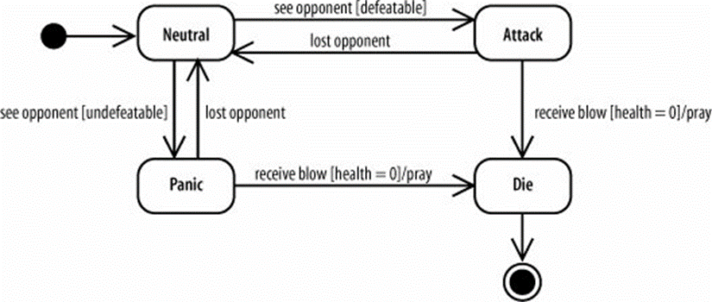

What is a state diagram: “It is a type of behavioral diagram, in the Unified Modeling Language (UML) shows transitions between various objects.” I also learned that state diagrams are also referred to as state machine diagrams. After studying and creating a few of my own diagrams are learned that their main purpose is showing they behavior of a system. The diagrams do an excellent job of showing transitions and different states that it is going through.

